Study that leaves prepare starch by the process of photosynthesis

Materials Required : A leaf of any plant, spirit, a beaker, test tube, burner, tripod stand, water, Petri plate, iodine solution, dropper, forceps.

Experimental Procedure:
1. Insert a leaf into a test tube gently with the help of forceps.
2. Pour spirit into the test tube so that the leaf completely dips in it.
3. Keep the test tube in a beaker half-filled with water.
4. Place the beaker on a tripod stand.
5. Boil the water till the spirit becomes green in colour and the leaf
becomes colourless.
6. Take out the leaf carefully from the test tube and wash it with water.
7. Place it in a Petri plate and add a few drops of iodine solution.
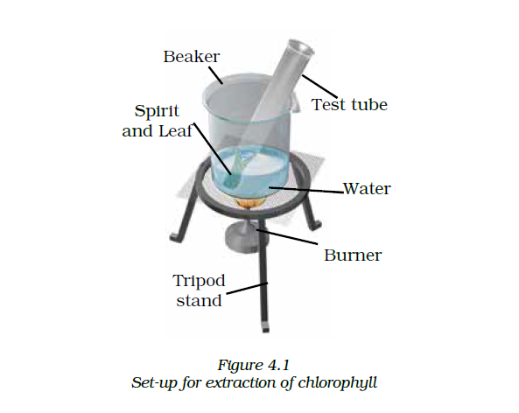
Observation: As we add iodine solution to the colourless leaf, it turns blue-black.

